Lab: Data Resources

Create a UI that looks similar to the following. The data must come from a resource in such a way that adding items to the resource adds items to the UI.

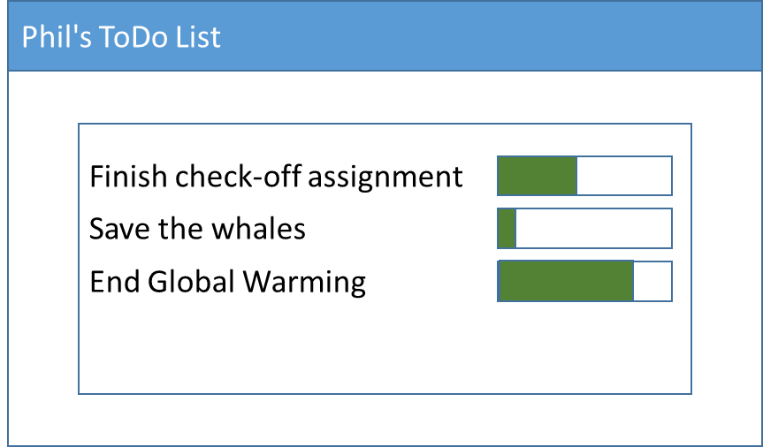

Add a button that initiates a long running process. The process could change the progress on one of the progress bars. The long running process must also update status in the task bar.

Add another UI control that can demonstrate that the UI is still responsive while your long running task is executing.

Note: ALL text must come from resources. This includes the title bar and the text on the buttons.